P.Bhavani

192021033

DAY 2 – LAB ASSESSMENT

1. 1.Write a R program to create an array of two 3x3 matrices each with 3 rows and 3 columns from two given two vectors. Print the second row of the second matrix of the array and the element in the 3rd row and 3rd column of the 1st matrix.

Program:

v1 = c(1,4,5,8)

v2 = c(1,3,5,7.9,10)

print(v1) print(v2)

result = array(c(v1,v2),dim = c(4,3,6)) print("New array:") print(result)

print("The second row of the second matrix of the array:") print(result[2,,2])

print("The element in the 3rd row and 3rd column of the 1st matrix:") print(result[3,3,1])

out put:

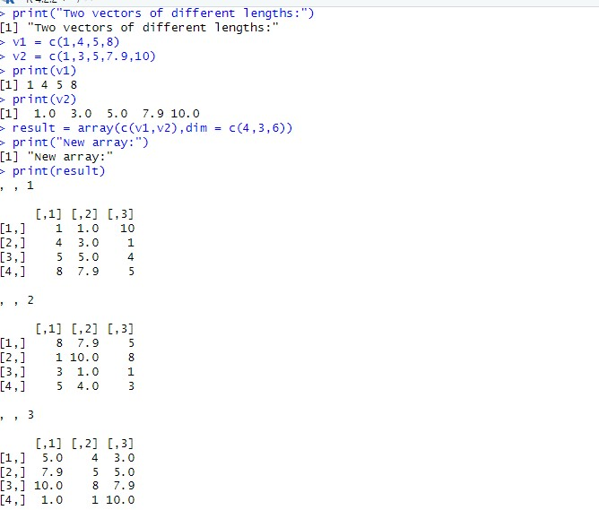

2. Write a R program to combine three arrays so that the first row of the first array is followed by he first row of the second array and then first row of the third array.

Program:

num1 = rbind(rep("A",3), rep("B",3), rep("c" ,3)) print("num1") print(num1)

num2 = rbind(rep("Q",3), rep("R",3), rep("S",3)) print("num2") print(num2)

num3 = rbind(rep("x",3), rep("y",3), rep("z",3)) print("num3") print(num3)

a=matrix(t(cbind(num1,num2,num3)),ncol=3,byrow=T) print("Combine three arrays,taking one row from each one by one:") print(a)

out put:

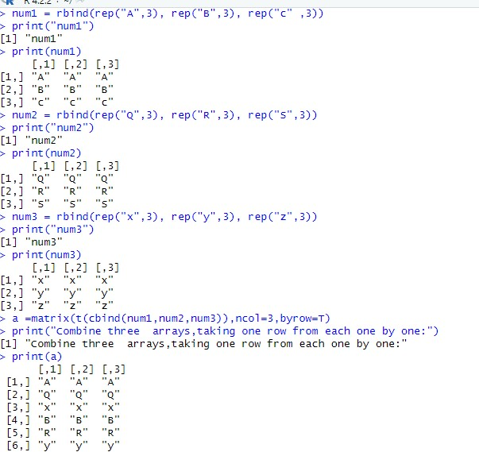

3. Write a R program to create an array using fourgiven columns array1 = array(1:30, dim=c(3,4,2)) print(array1)

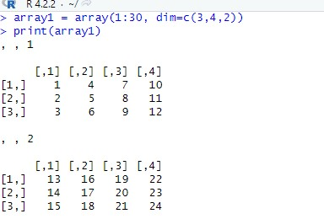

4 Write a R program to create a two-dimensional 5x3array of sequence of evenintegers greater than 50.

Program:

a <- array(seq(from = 50,length.out = 15,by = 2),c(5,3)) print("Content of the array:")

print("5*3 array of sequence of even integers greater than 50:") print(a)

out put:

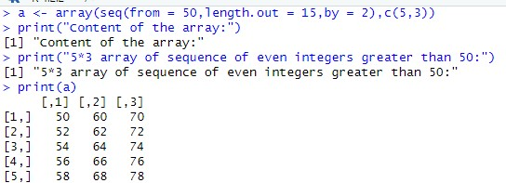

5. Write a R program to extract 3 rd  and 5 th  rows with 1 st  and 3 rd  columns from a given data frame

Program:

exam_data = data.frame(

name = c('Anastasia', 'Dima', 'Katherine', 'James', 'Emily',

'Michael', 'Matthew', 'Laura', 'Kevin', 'Jonas'), score = c(12.5, 9, 16.5, 12, 9, 20, 14.5, 13.5, 8, 19), attempts = c(1, 3, 2, 3, 2, 3, 1, 1, 2, 1),

qualify = c('yes', 'no', 'yes', 'no', 'no', 'yes', 'yes', 'no', 'no', 'yes')

)

print("Original datafram:") print(exam_data)

print("Extract 3rd and 5th rows with 1st and 3rd columns :") result = exam_data[c(3,5),c(1,3)] print(result)

out put:

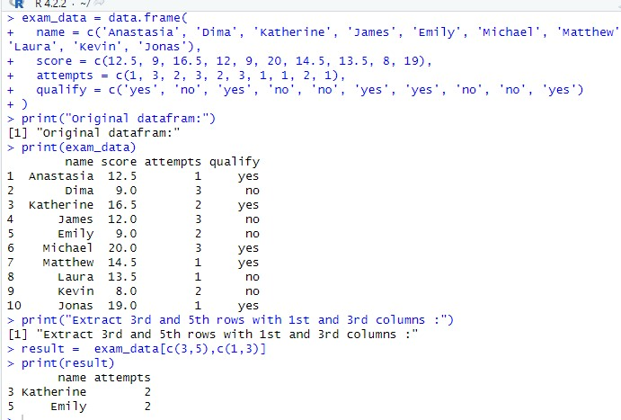

6.Write a R program to add a new column named country in a given data frame

Program:

Country<-

c("USA","USA","USA","USA","UK","USA","USA","India","USA",

"USA") exam_data = data.frame(

name = c('Anastasia', 'Dima', 'Katherine', 'James',

'Emily', 'Michael', 'Matthew', 'Laura', 'Kevin',

'Jonas'), score = c(12.5, 9, 16.5, 12, 9, 20, 14.5, 13.5, 8, 19), attempts = c(1, 3, 2, 3, 2, 3, 1, 1, 2, 1),

qualify = c('yes', 'no', 'yes', 'no', 'no', 'yes', 'yes', 'no', 'no', 'yes')

)

print("Original datafram:") print(exam_data)

print("New data frame after adding the 'country' column:")

exam_data$country =

c("USA","USA","USA","USA","USA","USA","USA","USA","USA"," USA") print(exam_data)

Output:

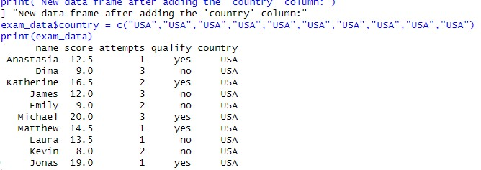

7. Write a R program to add new row(s) to an existing data frame

Program:

exam_data = data.frame(

name = c('Anastasia', 'Dima', 'Katherine', 'James', 'Emily',

'Michael', 'Matthew', 'Laura', 'Kevin', 'Jonas'), score = c(12.5, 9, 16.5, 12, 9, 20, 14.5, 13.5, 8, 19), attempts = c(1, 3, 2, 3, 2, 3, 1, 1, 2, 1),

qualify = c('yes', 'no', 'yes', 'no', 'no', 'yes', 'yes', 'no',

'no', 'yes')

)

print("Original datafram:") print(exam_data) new_exam_data = data.frame( name = c('Robert', 'Sophia'), score = c(10.5, 9), attempts = c(1, 3), qualify = c('yes', 'no')

)

exam_data = rbind(exam_data, new_exam_data)

print("After adding new row(s) to an existing data frame:") print(exam_data)

out put

:

8

Write a R program to sort a given data frame byname and score

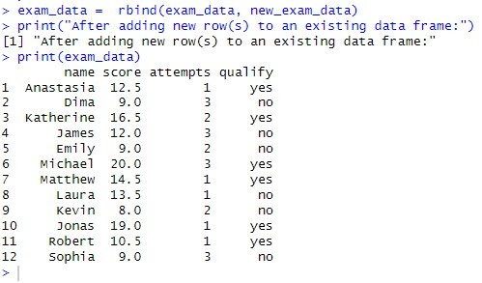

Program:

exam_data = data.frame(

name = c('Anastasia', 'Dima', 'Katherine', 'James', 'Emily', 'Michael', 'Matthew', 'Laura', 'Kevin',

'Jonas'), score = c(12.5, 9, 16.5, 12, 9, 20, 14.5, 13.5, 8, 19), attempts = c(1, 3, 2, 3, 2, 3, 1, 1, 2, 1), qualify = c('yes', 'no', 'yes', 'no', 'no', 'yes', 'yes', 'no', 'no', 'yes')

)

print("Original datafram:") print(exam_data) print("dataframe after sorting 'name' and 'score' columns:") exam_data = exam_data[with(exam_data, order(name, score)), ] print(exam_data)

Output:

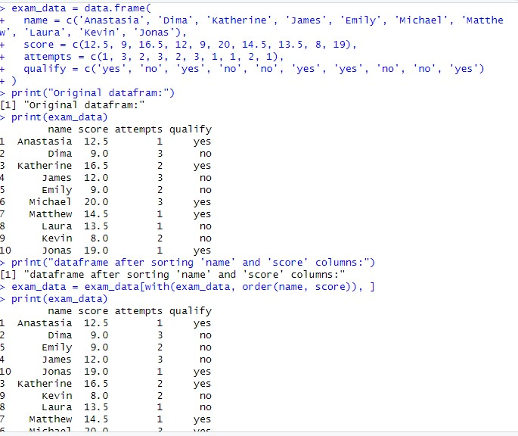

9.Write a R program to save the information of a data frame in a file and display the information of the file.

Program:

exam_data = data.frame(

name = c('Anastasia', 'Dima', 'Katherine', 'James', 'Emily', 'Michael',

'Matthew', 'Laura', 'Kevin', 'Jonas'),

score = c(12.5, 9, 16.5, 12, 9, 20, 14.5, 13.5, 8, 19), attempts = c(1, 3, 2, 3, 2, 3, 1, 1, 2, 1),

qualify = c('yes', 'no', 'yes', 'no', 'no', 'yes', 'yes', 'no', 'no', 'yes')

)

print("Original datafram:")

print(exam_data)

save(exam_data,file="data.rda") load("data.rda") file.info("data.rda")

Output:

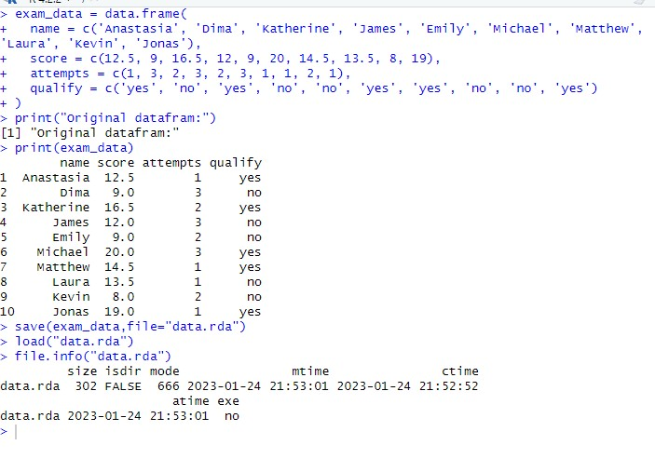

10. Write a R program to call the (built-in) dataset airquality. Check whether it is a data frame or

not? Order the entire data frame by the first and second column. remove the variables &#39;Solar.R&#39;

and &#39;Wind&#39; and display the data frame.

Program:

data = airquality

print("Original data: Daily air quality measurements in New York, May to September 1973.") print(class(data)) print(head(data,10)) result = data[order(data[,1]),]

print("Order the entire data frame by the first and second column:") print(result)

Output:

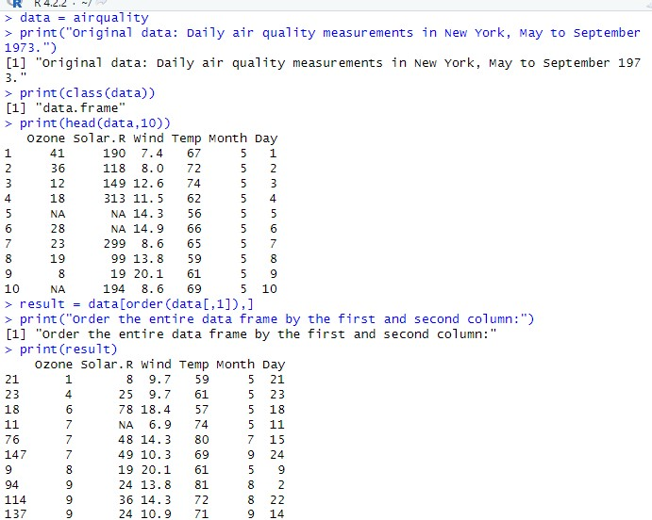

11.Write a R program to create a factor corresponding to height of women data set, which contains height and weights for a sample of women.

Output:

: 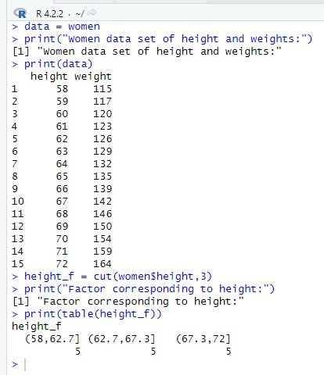

12. Write a R program to extract the five of the levels of factor created from arandom sample from the LETTERS (Part of the base R distribution.)

Program:

L = sample(LETTERS,size=50,replace=TRUE)

print("Original data:") print(L) f = factor(L)

print("Original factors:") print(f)

print("Only five of the levels") print(table(L[1:5]))

Output:

